PostgreSQL and PostGIS for Spatial Data Management and Analysis
As part of my coursework in the "Seminar for Geomatics," I undertook a project focusing on PostgreSQL and PostGIS, which involved several key steps and methodologies:
- Database Creation in PgAdmin4: I initiated the project by setting up a PostgreSQL database environment using PgAdmin4. Here I used the Ottawa Neighborhood shapefile.
- Spatial Extension Integration with PostGIS: I incorporated the PostGIS extension to enable spatial data management and analysis within PostgreSQL.

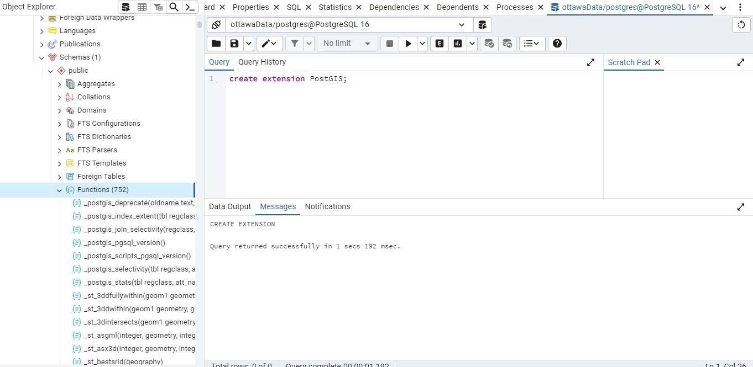

- Upload the spatial data: PostGIS bundle 3, is used efficiently in uploading geographic information system (GIS) data directly within the database.

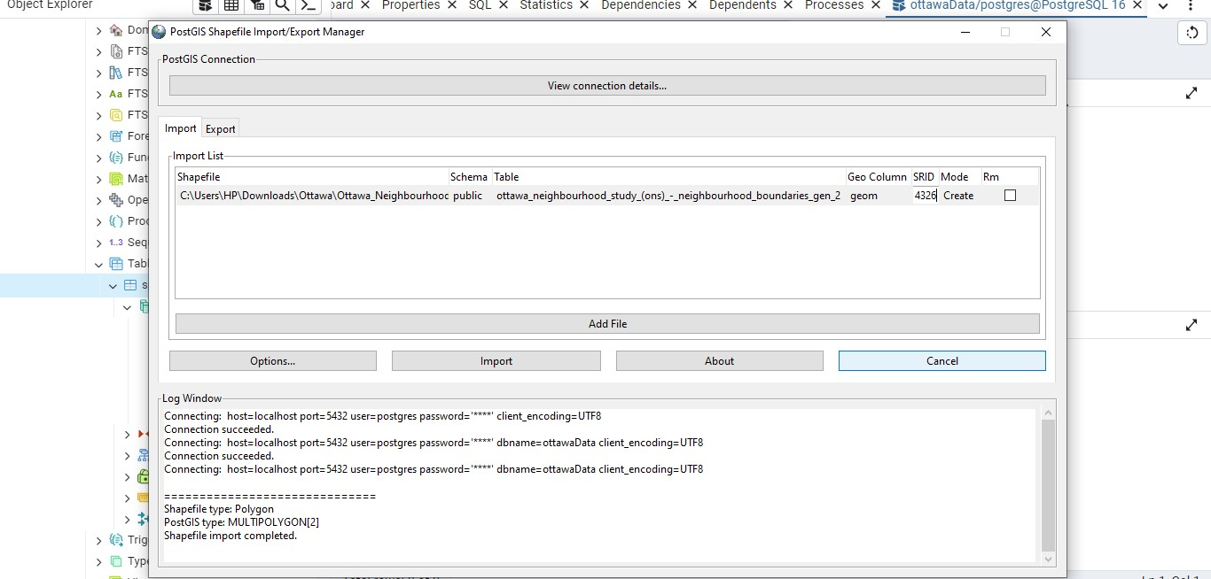

- Data Inspection and Validation in PgAdmin4: I meticulously inspected and validated the imported data within PgAdmin4. This phase ensured the integrity and accuracy of both spatial and attribute data before proceeding with further analyses.
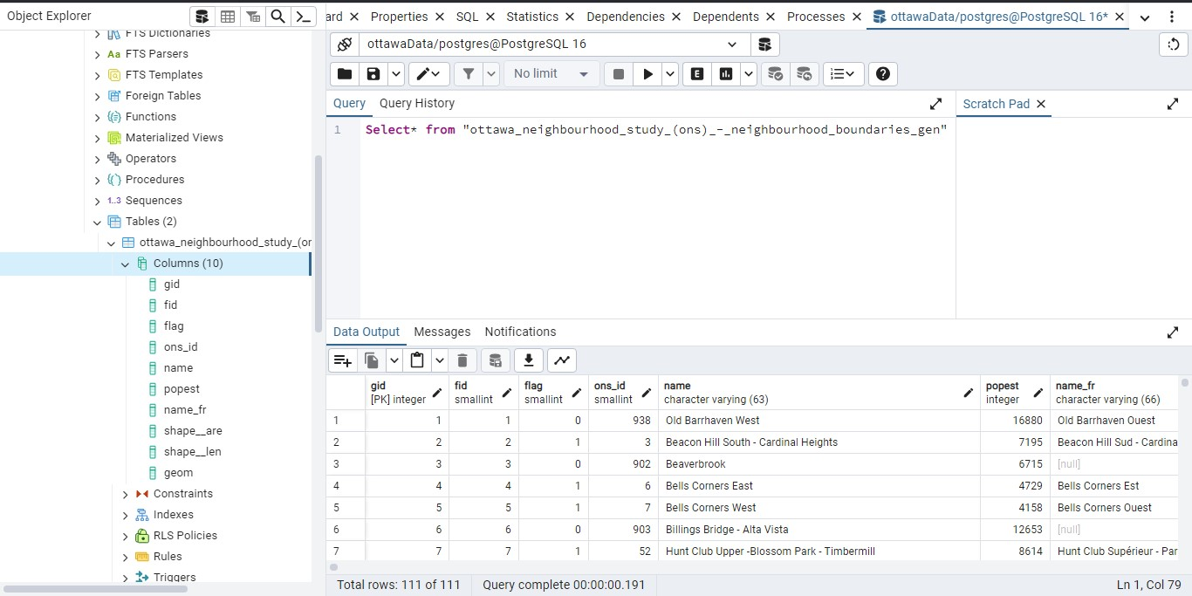
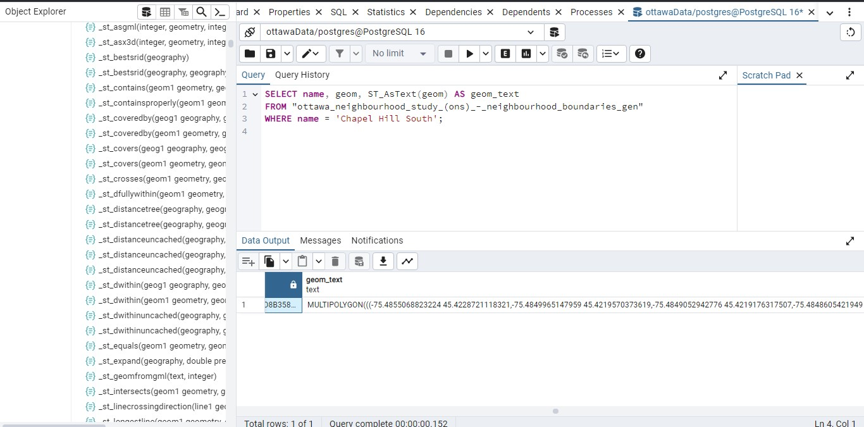

5(a)Spatial Reference System (SRS) Evaluation: I systematically reviewed and verified the SRS information associated with each spatial dataset. This step ensured that all spatial operations and analyses maintained spatial integrity and alignment with geographic standards.
(b)Reprojection of Spatial Data: As part of the project's spatial data management strategy, I executed reprojection tasks where necessary. Reprojection involved transforming spatial data from its original coordinate system to another, typically to ensure compatibility with standard geographic reference systems. This transformation was achieved using PostGIS functions like ST_Transform, ensuring consistent spatial analysis and visualization across different datasets.
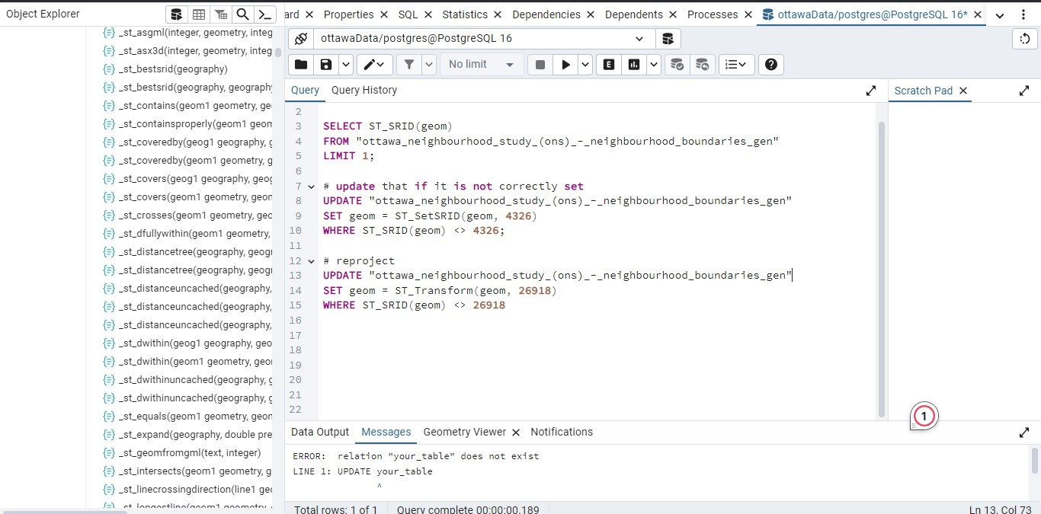
6. Distance Calculation from a Point: One of the core spatial analyses conducted in the project was calculating distances from specific points of interest. Leveraging PostGIS capabilities, particularly ST_Distance, I accurately computed distances between points within the spatial datasets. This functionality allowed for precise spatial measurements essential for various applications, such as proximity analysis and spatial querying.

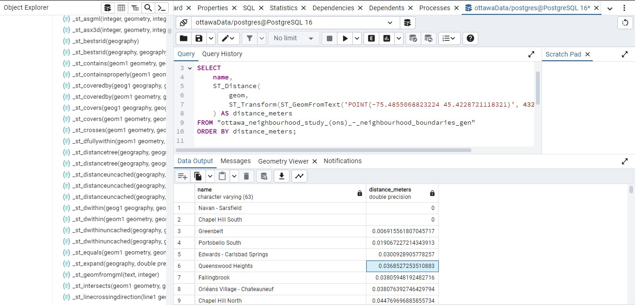

It should be noted that the database seamlessly connects to QGIS for additional visualization and inspection. A connection to QGIS is shown in below.
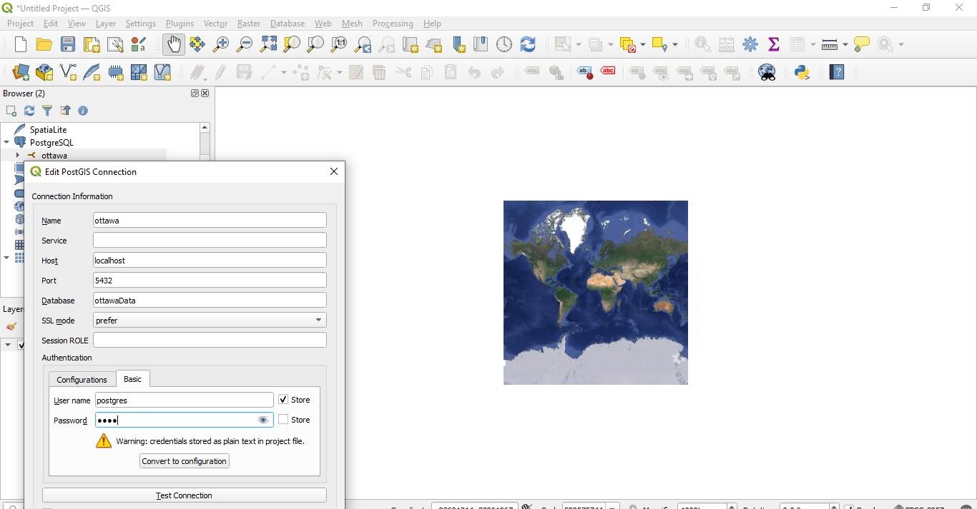

In summary, my project in PostgreSQL and PostGIS encompassed the setup of a spatially enabled database environment, integration of PostGIS for advanced spatial data management, data validation, and inspection, adherence to spatial reference standards, reprojection of spatial datasets for consistency, and accurate distance calculations from specified points.

